**Report on ‘Opening a new restaurants**’

**Introduction:**

I work at IBM office which is situated at Ozone3, SP Infocity, Hadapsar, Pune. In IT filed teams usually go for a team lunch or team dinner. For the teams working at this location will have to travel at least 5km to go to nearby places to find restaurants, bar etc. It’s good to have some coffee shop, restaurants and food courts near a IT park. People love to go these places and spend some time with friends or with team. As per some survey there are around 5k to 6k people are working in various companies in this IT park so, it will provide an opportunity to open new restaurant and if the quality of foods will be good that this will be a profitable business.

There are very few restaurants and food courts around this IT park so, I think there is opportunity to open new restaurants and food courts.

**Business Problem**:

Will it be profitable to open a new restaurant? What will be perfect location to open a new restaurant in Pune?

So, we will try to find out the below mentioned question to predict the possibility of opening a new restaurant

1. Is it profitable to open new restaurant?
2. How many restaurants is there around Hadapsar, Pune?

**Analytic Approach:**

Based on the count of restaurants and food courts we can predicts the chances of opening a new restaurants and food courts in this locality.

**Data:**

For my project “Opening a new restaurant”, I will use the below data from Foursquare API.

* Number of restaurant and food court data around Hadapsar, Pune.
* Location data of restaurant around Hadapsar, Pune.

Based on the call to Foursquare API it will give me the number of restaurants, its name and location where they are.

**Methodology:**

We will create a dataframe with the records of name of restaurant and food court, the count and the distance between them. We will use the statistical testing based on the count of restaurant and food court to predict the possibility of opening a new restaurant and food court in Hadapsar, Pune.

**Results: Data analysis**

1. Number of restaurant and food court in Hadapsar, Pune

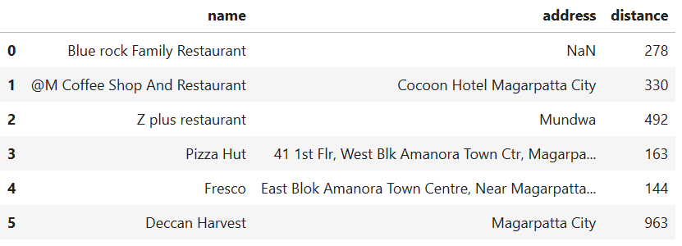

**Restaurants in Hadapsar**

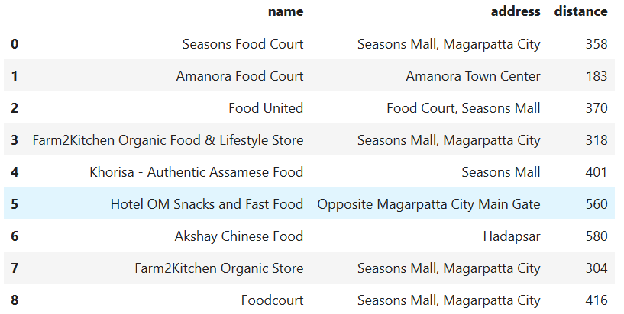

**Food court in Hadapsar**

1. Average of distance of each restaurant near from Convent Garden London

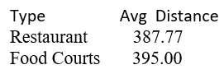

**Discussion section:**

Hadapsar is an industrial area where we have housing colony and four IT parks. A estimate says that there are around 10k people living in this area and most of them are working in IT filed. By seeing this number there are really very few restaurant and food court are there.

**Conclusion:**

For a place where we have 10k people and most of them are working professional we need more restaurant, coffee shop, bars so that people can go and enjoy good food with their team and friends. From the data we get we can open new restaurant in this area and we believe that it will be profitable.